**DAILY ONLINE ACTIVITIES SUMMARY**

|  |  |  |  |  |  |  |  |
| --- | --- | --- | --- | --- | --- | --- | --- |
| **Date:** | **01/07/2020** | | | | **Name:** | **Syed Rabeya Aamir** | |
| **Sem & Sec** | **8th B** | | | | **USN:** | **4AL16CS112** | |
| Online Test Summary | | | | | | | |
| **Subject** | | **___** | | | | | |
| **Max. Marks** | | **__** | | **Score** | | **---** | |
| Certification Course Summary | | | | | | | |
| **Course** | **INTRODUCTION TO INFORMATION SECURITY.** | | | | | | |
| **Certificate Provider** | | | **Great Learning** | **Duration** | | | **5.5 hrs** |
| Coding Challenges | | | | | | | |
| **Problem Statement:**  **1)**  Python code to demonstrate length of list using naive method. | | | | | | | |
| **Status: Solved** | | | | | | | |
| **Uploaded the report in Github** | | | | **YES** | | | |
| **If yes Repository name** | | | | **rabeya** | | | |
| **Uploaded the report in slack** | | | | **YES** | | | |

**Certification Course Details:**

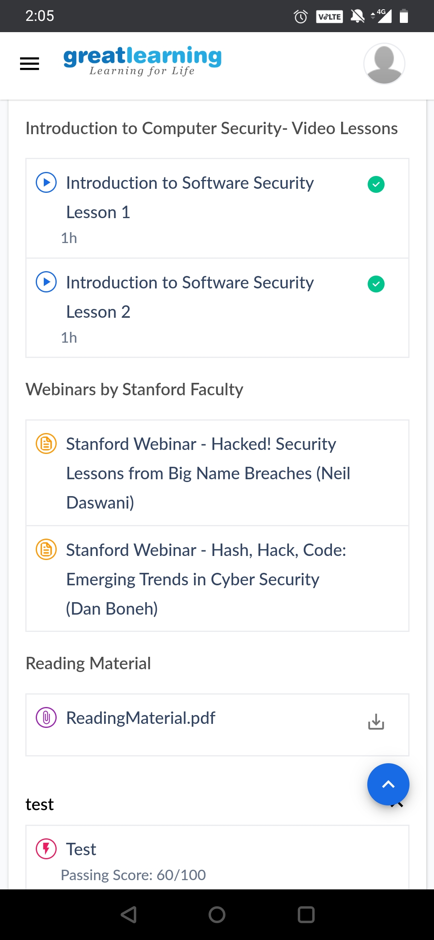

# CODE:

Program no:1

# Python code to demonstrate length of list using naive method.

# Initializing list

test_list = [ 1, 4, 5, 7, 8 ]

# Printing test_list

print ("The list is : " + str(test_list))

# Finding length of list

# using loop

# Initializing counter

counter = 0

for i in test_list:

# incrementing counter

counter = counter + 1

# Printing length of list

print ("Length of list using naive method")